

**Variable Refrigerant Flow Modeling**

**Using eQUEST**



**Forward**

Mitsubishi Electric has explored the modeling capabilities of several software programs as they relate to modeling energy performance and relative energy savings between variable refrigerant flow (VRF) systems and other standard systems. Mitsubishi Electric has provided input and collaboration with EnergySoft in developing accurate algorithms and proper inclusion of equipment unloading curve information relating to Mitsubishi Electric VRF equipment for use in EnergyPro.

Mitsubishi Electric recognizes the desire in the industry among design professionals to utilize software they are trained on, are accustomed to using, and have invested money in. For this reason it is Mitsubishi Electric’s intent to try and provide information as accurate as possible for use in eQUEST as it pertains to our VRF equipment.

Mitsubishi Electric, however, does not have access to, nor is part of the background programming or algorithms inside the DOE2.2 computational engine. Mitsubishi Electric has provided a method to approximate the energy consumption of VRF using the available modeling capabilities in eQUEST.

The following pages summarizes the known limitations, as well as provides guidance for the designer on how to, within the capabilities of the eQUEST software, utilize our equipment library information. A sample .inp file can be made available to more easily import custom curve data into the project.

***It is the designer’s responsibility to assess all information contained in any equipment library file and to apply sound engineering judgment and evaluation when performing any energy model. Mitsubishi Electric & Electronics USA, Inc. assumes no responsibility for the accuracy of this information used within the context of the eQUEST software, nor for the misuse or extrapolation of data taken from this document or accompanying .INP file. Mitsubishi Electric & Electronics USA, Inc. makes no warranties or financial guarantees based on any information stated in this report or data contained within the accompanying .INP file.***

**Known Limitations & Clarifications**

1. The actual heating ambient unloading curves within EQUEST can only be defined for a single temperature range. Mitsubishi Electric’s VRF equipment heating ambient curves are different for different ambient temperature ranges. Trying to define a single bi-quadratic curve for all ambient conditions introduces significant error along the curve fit compared to actual tested conditions.
2. All the Mitsubishi Electric nominal capacity, peak power, and modification curves are for the outdoor compressor unit as a whole. The EQUEST library files for air to air heat pumps have the option for condenser fan power to be defined separately. This value in the Mitsubishi Electric library files has been zeroed out since condenser fan energy is already included in peak power values and part load custom curves.
3. No Mitsubishi Electric water source VRF equipment curves have been provided in the accompanying .INP file. While similar approximations to those described in this paper can be made for the water source equipment, there will still be limitations within the capabilities of eQUEST.
4. eQUEST doesn’t have the capability to directly model the heat recovery operation of VRF equipment. This paper will describe some methods for performing additional calculations using the results and outputs from eQUEST to make an approximation of the heat recovery savings.

**EQUEST Modeling Notes**

There are several different system choices that have been suggested for modeling VRF in eQUEST. While all of these systems are and acceptable choice, there are certain systems that can better utilize the curves that can be provided by VRF manufacturers.

Several suggestions have been made to model VRF systems as PVVT systems, which will allow variable speed compressors to be used. It is not absolutely necessary to use a variable speed compressor to approximate VRF systems in eQUEST. Selecting a variable speed compressor will require that an additional low speed curve be used based on compressor RPM. This makes it more difficult to directly use the curves that can be provided by VRF manufacturers. The PLR curves, EIR curves, and capacity curves provided by the manufacturer should address the variable operation of VRF systems. It is because of this that PSZ is used for modeling described in this paper. When modeling VRF systems, it is generally best to break up each individual indoor unit as its’ own mechanical system. This will help to better approximate the variable nature of VRF and better mimic the real world operation of a VRF system.

Although this paper uses PSZ systems to model VRF, PTAC systems can also be used to model VRF systems. Depending on the baseline system this approach may be easier, but keep in mind that the PSZ system may make it easier to add Energy Recovery Ventilation in conjunction with the VRF system. Similar methods to those described can also be applied to PVVT systems.

Many of the modifications shown below can also be done in the spreadsheet view to save time.

**EQUEST Modeling : Importing Curves**

Start out by modeling the building and zoning the building as you normally would in eQUEST. If using the wizard to create the shell and zone the building, it will be easier if PSZ is selected as the HVAC system in the wizard. This will create the building so that each individual zone gets assigned to a thermal zone and an individual PSZ system.

Once the building construction has been created and zoned, switch from the wizard input mode to the detailed input mode. The file can now be saved and temporarily closed to copy the custom curves into the project .INP file.

Save and close the project, then locate the project .INP file. The project .INP file can be found in the folder where the project has been created. The .INP file can be opened using notepad. Once opened, search for the term “performance” using ctrl+f. Copy and Paste the custom curves from the provided .INP as shown below:

Curves shown are based on those created for use in Trane Trace and data from the Engineering Manual

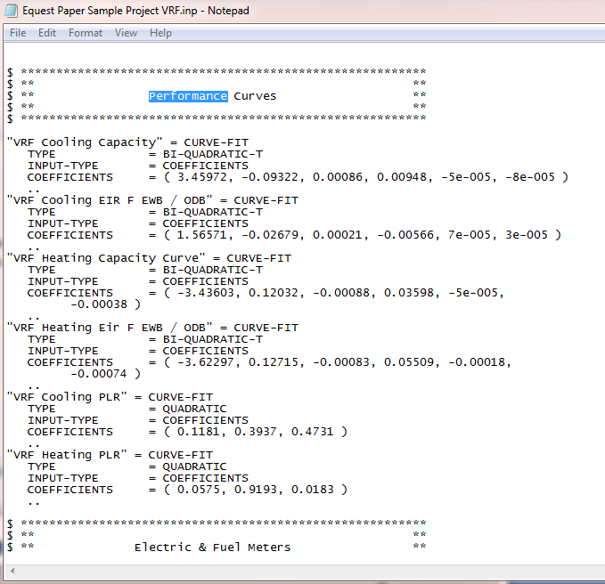

**EQUEST Modeling: Fan Power**

Once the curves have been inserted into the .INP file, save and close the file then reopen the project. Go to the Air-Side HVAC system tab and begin to modify the PSZ system. Start by modifying the fan power by going to the Fans – Fan Power and Control tab.

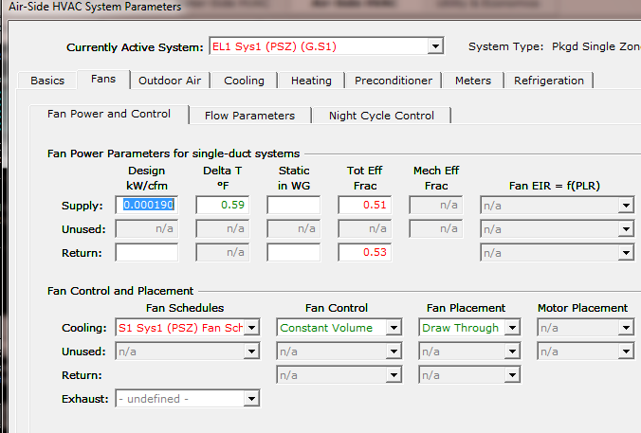

Ensure that the fan control is defined as constant volume, and modify the Design kw/CFM. Information to calculate the kw/cfm can be found on the indoor unit submittal. See below for detail:

|  |  |  |  |
| --- | --- | --- | --- |
| ***Indoor Unit Power in kW/CFM*** | | | |
| Mitsubishi Electric Indoor Unit Model | CFM | Input power kW | kW/CFM |
| PEFY-P24NMAU-E2 | 883 | 0.17 | 0.000193 |
| PLFY-P24NBMU-E | 706 | 0.06 | 0.000085 |
| PKFY-P18NBMU-E2 | 425 | 0.03 | 0.000071 |

**EQUEST Modeling: Cooling and Heating EIR**

The next step is to define the cooling and heating EIR. This will define the efficiency of the outdoor unit. This can again be calculated using the information provided on the outdoor unit submittal:

|  |  |  |  |  |  |  |
| --- | --- | --- | --- | --- | --- | --- |
| ***Outdoor Unit Cooling and Heating EIR values*** | | | | | | |
| Mitsubishi Electric Outdoor Unit Model | Cooling Capacity | Cooling Power Input | Cooling EIR | Heating Capacity | Heating Power Input | Heating EIR |
| PURY-P72T(Y)KMU | 72000 | 4.4 | 0.209 | 80000 | 5.92 | 0.253 |
| PURY-P96T(Y)KMU | 96000 | 7.05 | 0.251 | 108000 | 8.28 | 0.262 |
| PURY-P120T(Y)KMU | 120000 | 9.44 | 0.268 | 135000 | 10.86 | 0.275 |
| PURY-P144T(Y)KMU | 144000 | 11.2 | 0.265 | 160000 | 13.54 | 0.289 |
| PURY-P144YSKMU | 144000 | 10.31 | 0.244 | 160000 | 12.54 | 0.267 |
| PURY-P168T(Y)SKMU | 168000 | 12.8 | 0.260 | 188000 | 14.91 | 0.271 |
| PURY-P192T(Y)SKMU | 192000 | 15.61 | 0.277 | 215000 | 17.2 | 0.273 |
| PURY-P216T(Y)SKMU | 216000 | 18.22 | 0.288 | 243000 | 19.89 | 0.279 |
| PURY-P240T(Y)SKMU | 240000 | 21.11 | 0.300 | 270000 | 22.73 | 0.287 |
| PURY-P264T(Y)SKMU | 264000 | 23.05 | 0.298 | 295000 | 25.37 | 0.294 |
| PURY-P288T(Y)SKMU | 288000 | 24.57 | 0.291 | 320000 | 27.62 | 0.295 |
| PUHY-P72T(Y)KMU | 72000 | 5.06 | 0.240 | 80000 | 5.62 | 0.240 |
| PUHY-P96T(Y)KMU | 96000 | 7 | 0.249 | 108000 | 7.47 | 0.236 |
| PUHY-P120T(Y)KMU | 120000 | 9.09 | 0.259 | 135000 | 10.28 | 0.260 |
| PUHY-P144T(Y)KMU | 144000 | 11.84 | 0.281 | 160000 | 12.47 | 0.266 |
| PUHY-P144YSKMU | 144000 | 10.57 | 0.251 | 160000 | 11.68 | 0.249 |
| PUHY-P168T(Y)SKMU | 168000 | 12.71 | 0.258 | 188000 | 14.02 | 0.255 |
| PUHY-P192T(Y)SKMU | 192000 | 14.81 | 0.263 | 215000 | 16.91 | 0.268 |
| PUHY-P216T(Y)SKMU | 216000 | 16.9 | 0.267 | 243000 | 19.26 | 0.271 |
| PUHY-P240T(Y)SKMU | 240000 | 19.12 | 0.272 | 270000 | 21.86 | 0.276 |
| PUHY-P264T(Y)SKMU | 264000 | 20.35 | 0.263 | 295000 | 23.11 | 0.267 |
| PUHY-P288T(Y)SKMU | 288000 | 22.39 | 0.265 | 320000 | 25.36 | 0.270 |
| PUHY-P312T(Y)SKMU | 312000 | 24.87 | 0.272 | 350000 | 28.71 | 0.280 |
| PUHY-P336T(Y)SKMU | 336000 | 27.21 | 0.276 | 378000 | 31.73 | 0.286 |
| PUHY-P360T(Y)SKMU | 360000 | 29.65 | 0.281 | 405000 | 35.39 | 0.298 |

**EQUEST Modeling Cooling Modifications:**

On this tab, the cooling EIR should be entered from the table above. The performance curves for VRF should be selected and the crankcase heat should be set to 0. The crankcase power is included in the EIR value.

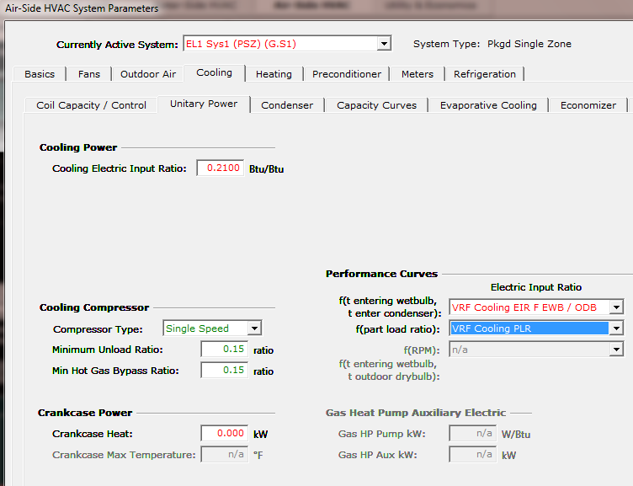

**EQUEST Modeling Cooling Modifications:**

On the Capacity curves tab, the VRF capacity curve will need to be selected and the min temp used in cooling curves should be set to 50°F

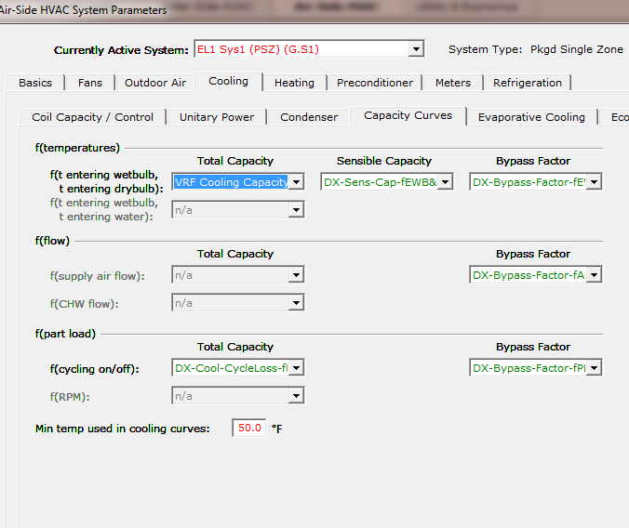

**EQUEST Modeling Heating Modifications:**

On the heating coil cap tab, ensure that there is no zone heat source installed.

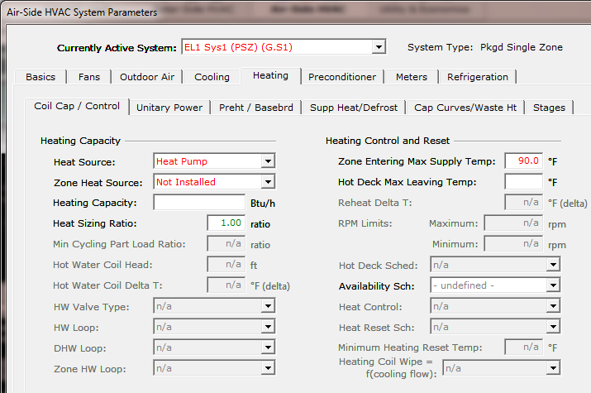

**EQUEST Modeling Heating Modifications:**

On the heating unitary power tab, the heating EIR can be entered from the table above and the VRF heating power curves can be selected.

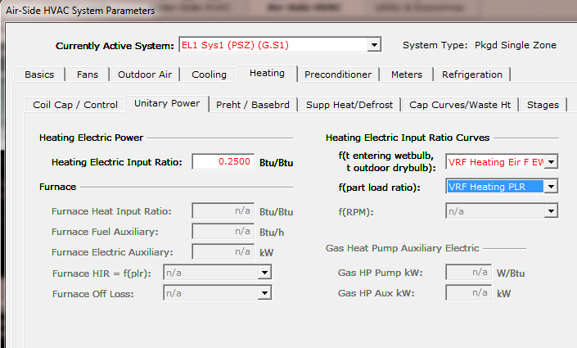

**EQUEST Modeling Heating Modifications:**

On the heating capacity curves tab, the heating capacity curve should be selected.

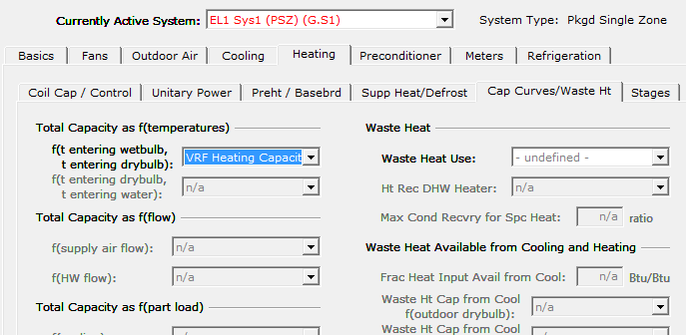

**EQUEST Modeling Heating Modifications:**

On the heating supplemental heat tab, this tab will need to be modified based on the project design. Many VRF systems are designed will no supplemental heat and as such the supplemental heat should be set to “Not installed”. If supplemental heat is installed, the Min HP heat Temp and Max HP Supp Temp should be adjusted to meet the project design.

The Defrost should be adjusted to be Reverse Cycle and on Demand to match the way that VRF systems defrost.

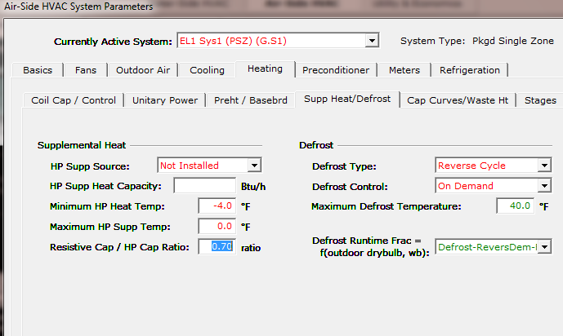

**EQUEST Modeling Heating Recovery Approximation:**

eQUEST does not have the capability to model the heat recovery feature of VRF systems. That being stated, there are methods to approximate the savings seen through heat recovery, by using hourly outputs and reports. Each VRF outdoor system can be set on an individual electric meter, and then define an hourly report for each meter to report the cooling and heating end use. Export the hourly reports to a CSV file so that they can be viewed and manipulated in excel. Analyze the excel data to delete the cooling energy consumption when the heating energy consumption is larger for a given hour on a single outdoor system. When the cooling energy is larger than the heating energy, the heating energy can be cut in half. This method is not perfect nor completely accurate, but it is the best way to approximate the heat recovery savings using eQUEST.

**Conclusion/Summary**

The eQUEST software is a robust and complex modeling software program; however, Mitsubishi Electric has neither affiliation nor input into its’ computational engine.

Mitsubishi Electric is focused, however, on providing support to engineers and designers to the extent possible to allow them to model VRF systems with software they are trained on and accustomed to using.

Again, it is intended that this information be used as a general guide offering some additional accuracy when modeling Mitsubishi Electric equipment for air cooled systems in the eQUEST software.

However, it is ultimately the designer / engineer of record’s responsibility to access all information provided.